

**Lab no.: 2 Date: February 11, 2024**

**Write a recursive program to find the Fibonacci series of given input.**

In Mathematics, the **Fibonacci numbers** are the numbers ordered in a distinct**Fibonacci sequence**. These numbers were introduced to represent the positive numbers in a sequence, which follows a defined pattern. The list of the numbers in the **Fibonacci series** is represented by the recurrence relation: 0, 1, 1, 2, 3, 5, 8, 13, 21, 34, 55, ……., ∞

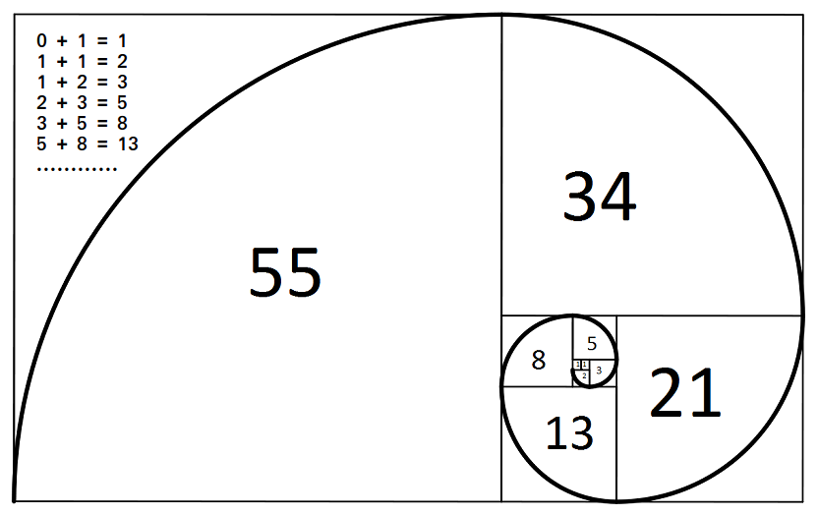

Figure 1: Fibonacci Series

**Programming Language: C**

**IDE: Microsoft Visual Code**

**Source code:**

#include <stdio.h>

int fibo(int n)

{

if (n == 0 || n == 1)

return n;

else

return fibo(n - 1) + fibo(n - 2);

}

void output(int n)

{

printf(" %d,", n);

}

int main()

{

printf("\n....FIBONACCI SERIES....\n");

int n;

printf("Enter the number of terms: ");

scanf("%d", &n);

printf("The fibonacci series is: \n");

for (int i = 0; i < n; i++)

{

printf("%d,", fibo(i));

}

}

**Outputs:**

